Blabberize Center:
- Log on to the computer.
- Work with your partner to create a script about Pedro Menendez de Aviles. You must use three facts that you learned during the read aloud.
- Go to www.blabberize.com/make
- Use the picture of Pedro Menendez de Aviles in the Student Resources folder to create a Blabberize about him.
- When you are done, save your Blabberize to the student work folder. Make sure your names are in the file name.

Voyager’s Journal Center:
- Get your journal from your treasure chest.
- Write down the weather and water conditions like you are Pedro Menendez de Aviles telling a ship captain who is about to sail out of St. Augustine.
- Write a daily journal as Pedro Menendez de Aviles. Tell the king and queen of Spain three things about St. Augustine.
- When you are done, put your voyager’s journal back in your treasure chest.

Build the Castillo de San Marcos Center:
- Work together to use the clay to build one corner of the Castillo de San Marcos. Use the picture to help you. You need to build the part in the red box.
- Make your walls one inch thick, two inches tall, and two inches long. Choose one member of your group to be the person who measures it with the ruler.
- When you are done, choose one person who was not the ruler person to carefully carry your model to the counter. Do not touch any of the other groups’ models.
- After all four groups have made their models, we will put them all together to make a complete Castillo de San Marcos!
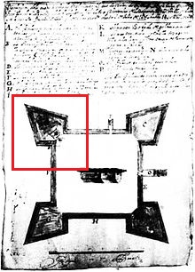
Source:http://www.nps.gov/history/history/online_books/source/sb3/images/sb3f.jpg

